**Date:**08/10/2015  
**To:** kate_mason@scrassociates.com  
**From:** jesse_baker@scrassociates.com   
**Subject:** Task completion estimates

Hi Kate,

When you work on the Microsoft Excel spreadsheet to calculate the task completion estimates, you can use the textbook formula we discussed – you’ll find it on page 102 of your systems analysis book. I’m sure you’re very familiar with spreadsheet design, but here are a couple of suggestions:

When you create the formula, don’t “hard-code” the values you want to plug in. In other words, the values for B, P, and W should be in separate cells that are referenced by the formula. Here’s an example:  
  
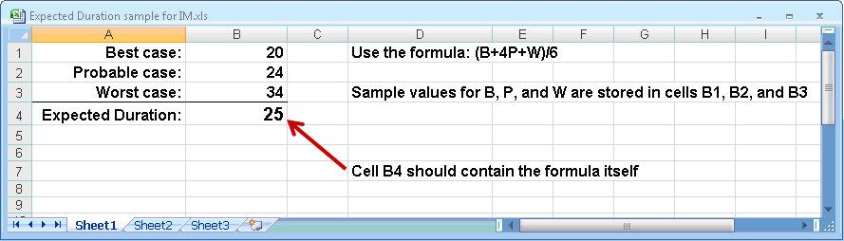

If you have any questions, please let me know.

Jesse Baker